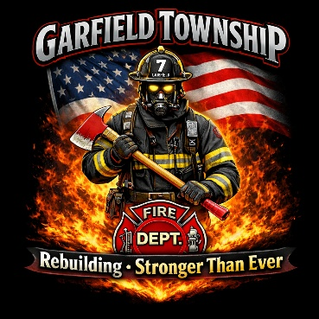
Garfield Township Fire Days Investment Opportunities

The Garfield Township Volunteer Fire Department has long stood as a pillar of strength and service in Bay County, Michigan. Following the devastating station fire on October 30, 2025, which resulted in a total loss of the facility and equipment, this dedicated all-volunteer team remained steadfast in its mission to protect and serve. Today, they are not only rebuilding a station—but restoring a vital community resource.

On June 13, Garfield Township Fire Days will bring the community together in support of furnishing the new station, including a much-needed EMS rescue bay. This family-friendly event will feature interactive attractions, local vendors, and live demonstrations, transforming a story of loss into one of resilience and renewal.

Your sponsorship plays a critical role in helping make this vision a reality. By partnering with us, you are investing in the safety, strength, and future of the entire community. We invite you to join us in rebuilding—stronger than ever.

Event Sponsorship Form

Rebuilding More Than a Station—Healing Hearts Together
Choose the tier that best matches your impact. Every level helps rebuild the station and heal hearts.

Each level includes a plaque or recognition on a plaque in the new fire station.

Phoenix Partner (Event Sponsor) – $5,000 (limit 1)
Rise from the ashes as our flagship supporter. Funds major station furnishings and overall event.
- Logo on main banner and event flyer
- Program recognition by Chief Neumeyer
- Event display table
- Social media recognition
- Website recognition

Forge Builder (Attraction Sponsor) – $2,500 (limit 2)
Help forge a stronger future. Supports key equipment and attraction areas.
- Logo on attraction signage and event flyer
- Event display table
- Social media recognition
- Website Recognition

Beacon Guardian (Food/Beverage Sponsor) – $1,000 (limit 5)
Be the guiding light for volunteer honors and community spirit. Supports food and refreshments.
- Logo on food/beverage signage and event flyer
- Social media recognition

Ember Sustainer – $500 (limit 10)
Keep the volunteer fire burning bright. Supports presentation and recognition efforts.
- Logo on presentation signage
- Social media recognition

Spark Supporter – $250 (no limit)
Ignite community solidarity with a spark.
- Name listed on support signage at event
- Social media recognition

Friend of Our Volunteers – Any Amount (no limit)
Donate what fits your budget and still be part of the rebuild.

Raffle Prize Donation – Any Amount (no limit)
Raffle donations will be displayed with donor cards at event

Sponsor Information (please print or type)
Business / Organization Name: _______________________________________________________________
Contact Person: ____________________________________________________________________________
Address: ___________________________________________________________________________________
Phone: _______________________________ Email: _______________________________________________
I / We would like to sponsor (list sponsor level)__________________________ Tier for $_______________
I/We would like to donate a raffle prize(s) for the event (please list): ____________________________________________________________________________________________

Signature: _______________________________ Date: ________________

Submission Instructions: Email completed form and logo (if applicable) to:
Fire Chief Bryan Neumeyer – gtfdneumeyer@gmail.com, or
Assistant Fire Chief Becky Hoffman – gtfdhoffman@gmail.com
Questions? Call 989-879-2552 ext. 226

Checks made payable to
Bay Area Community Foundation — c/o Garfield Fire Department

Thank you for standing with the Garfield Township Volunteer Fire Department

